**Дата**: 26.11.2024

**Клас**: 5-Б

**Предмет**: англійська мова

**Тема:** Готуємо мафіни.

**Мета:** : формувати навички вживання лексичних одиниць по темі; удосконалювати навички читання, аудіювання й усного монологічного мовлення; розвивати пізнавальні інтереси учнів; виховувати інтерес до самостійного пошуку потрібної інформації, а також загальну культуру учнів.

**Вчитель**: Руда Д.В.

Хід уроку

1.Greeting

Good afternoon, guys! I’m glad to see you. Are you ready to start our lesson? All set?

2. Wаrm up / Listening

Уважно слухати аудіо трек і дати відповідь на питання вчителя <https://english-practice.net/english-listening-exercises-for-a1-food/> .

3. Speaking

* Which country's food do you like the most?
* Which do you eat more often, rice, bread or potatoes?
* Which fast food restaurants do like?
* Which fast food restaurants do you eat at the most often?
* Who do you usually eat dinner with?
* Why are diets usually short?
* Why can't people stop eating?
* Why do you think obesity is becoming such a problem in the United States and throughout the world?
* What do Chinese people eat for lunch?(Substitute the nationality of your students.)
* Do you know the nutritional value of the things you eat every day?
* Do you believe that "we are what we eat?"
* How many meals a day do you think should be eaten?
* Do you usually eat at home or eat at a restaurant?
* Can you name a spice or flavoring that is good for your health?
* If you were on death row, what would you request for your last meal?
* Do you pray before each meal?
* Have you ever eaten something that made you ill?
* How many calories are in one hamburger?
  + If you don't know, can you make a guess? Is it more or less than an ice-cream cone?
* Have you ever had pot-luck?
* Have you ever tasted African food?
* Does your family have any special recipes that are passed down from generation to generation?
* What would you bring to a pot-luck lunch?
* Do you like brunch?

4. Повторення

Повторення irregular verbs :

|  |  |  |
| --- | --- | --- |
| Lose (луз) | lost | Lost - загубити |
| make | made | Made - робити |
| Mean (мін) | meant | Meant - означати |
| Meet (міт) | Met (мет) | Met- зустрічати |
| Pay(пей) | Paid(пейд) | Paid(пейд)- платити |
| put | put | Put- класти |
| Run(ран) | Ran(рен) | Run(ран)- бігти |
| Say(сей) | Said(сед) | Said- казати |
| See(сі) | Saw(со) | Seen(сін)- бачити |

5. Writing

Виконати вправи на простий минулий час. <https://wordwall.net/uk/resource/16264106/english/irregular-verbs-smart-junior-3>

<https://wordwall.net/uk/resource/54194636/%d0%b0%d0%bd%d0%b3%d0%bb%d1%96%d0%b9%d1%81%d1%8c%d0%ba%d0%b0-%d0%bc%d0%be%d0%b2%d0%b0/past-simple-irregular-verbs-negatives>

<https://wordwall.net/uk/resource/72827196/%d0%b0%d0%bd%d0%b3%d0%bb%d1%96%d0%b9%d1%81%d1%8c%d0%ba%d0%b0/%d0%b2%d0%bf%d1%80%d0%b0%d0%b2%d0%b0-2>

Акцентувати увагу на правильних та неправильних дієсловах.

Виконати вправу 5 стр 54.

1. Проаналізувати схему подану нижче.

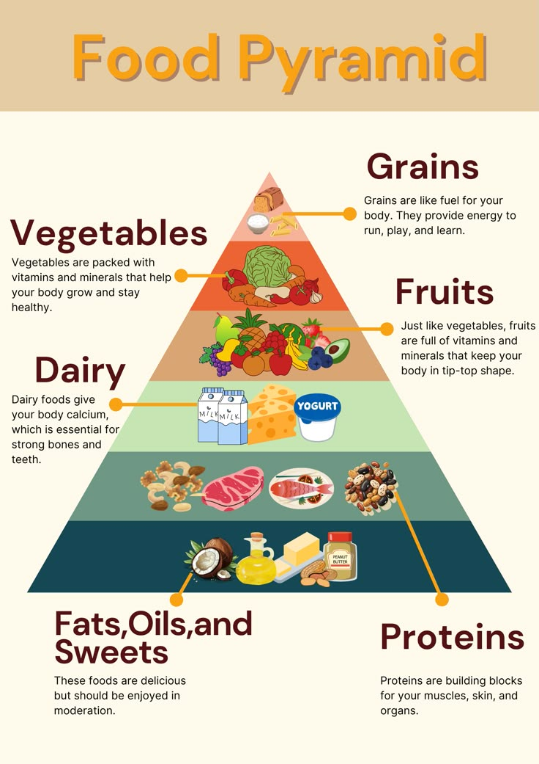

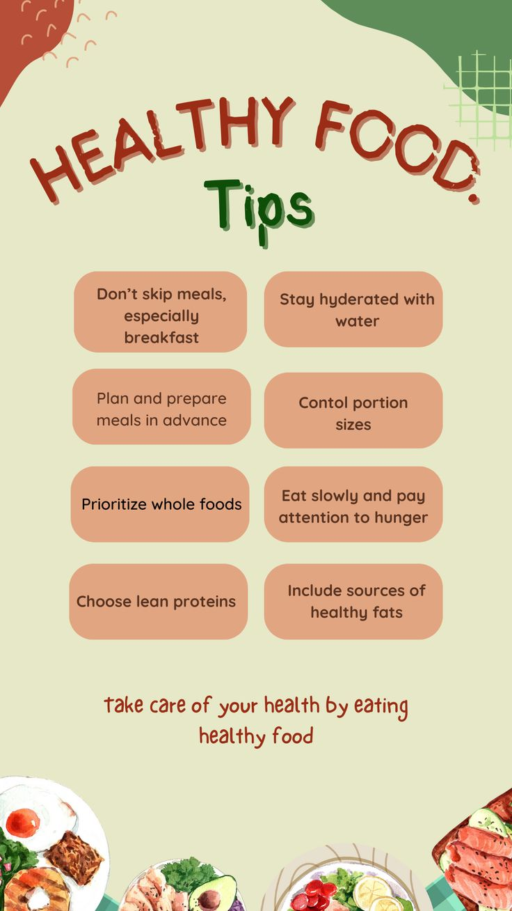

6. Homework

1. Виконати письмово вправу 6 стр 54.

2. Вивчити неправильні дієслова напам’ять.